Species List
Underwater Surveyor uses a species list to help the user select the correct fish species from a pick list. This primarily ensures species naming is consistent and allow exported data from resulting surveys to be collated.
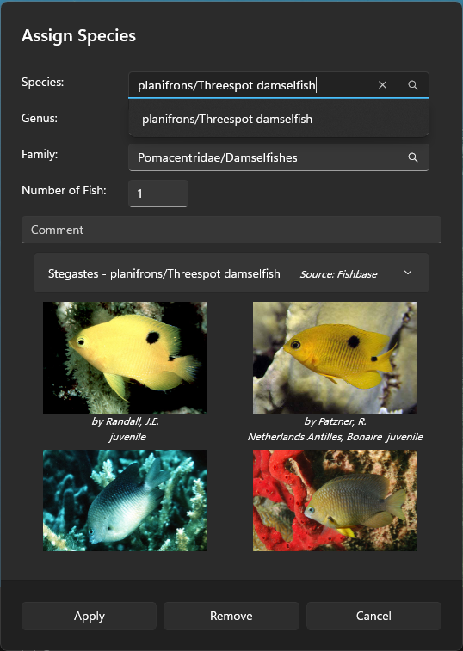
The species list contains four items:
- Family
- Genus
- Species
- Unique Species ID
The preferred format is to present the Family and Species as Latin name/Common name and for the Unique Species ID to be the ID used by FishBase in the form: Fishbase:<ID>. Below is an example of a three line from a species list:
Holocentridae/Squirrelfishes Sargocentron bullisi/Deepwater squirrelfish FishBase:3622
Kyphosidae/Chubs Kyphosus sectatrix/Bermuda chub FishBase:2498
Labridae/Wrasses Bodianus parrae/Creole wrasse FishBase:3656

The use of the FishBase ID as the Unique Species ID allow the application to automatically download the species images from FishBase to help the user with species identification.

Predefined Species Lists
Underwater Surveyor comes with predefined region specific lists.
[Add how to find and select those list]

New Species List
You can also create your own Species List.
[How to create a name a new list]
[How to populate the species list one by one through the ID]
[How to batch create a new species list using the command line utility]

Add to or Remove from Species List
[use to add/remove from a species list]

Exporting a Species List

